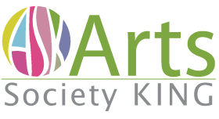 Enriching King Township through arts and culture for all
Annual General Meeting - Agenda
Call to order.
Approval of the Minutes of the last AGM – November 2019
Approval of the Financial Statements
Election of Directors
Directors are elected for a term of 2 years.
The current board has 7 directors.
Two directors are leaving the board: Elaine Robertson and Blair Day. We thank them for dedication and service on the board.
Three Directors continue into the second year of their term:
- Murdene Pozdrowski,
- Lynda Rogers,
- Len Vernon
The following directors, whose term has ended, have agreed to continue as directors:
- Michele McNally
- Dorita Peer

- In addition, the following have agreed to become directors
  - Terri Vetter, a long-time supporter of ASK, and
  - Kathleen Rodgers, an artist and key organizer of the 2020 Studio Tour.
Motion to nominate the following to be directors of Arts Society King for a term ending with the AGM in 2022.
- Michele McNally,
- Dorita Peer,
- Kathleen Rodgers
- Terri Vetter
Therefore … the executive committee of A.S.K. for the coming year will be as follows:
- Michele McNally President and Chair of the Board.
- Lynda Rogers Past President
- Murdene Pozdrowski Secretary
- Len Vernon Treasurer
Adjournment
Following the AGM there will be an information presentation.

